Money Matters Cards Explained

An annual percentage rate (APR) is the annual rate charged for borrowing or earned through an investment, and is expressed as a percentage that represents the actual yearly cost of funds over the term of a loan.
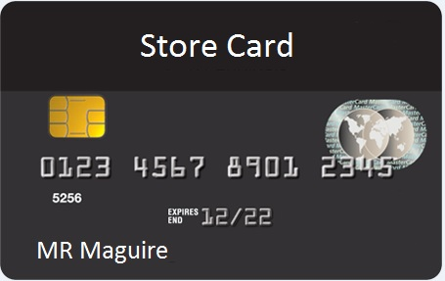
A store card is card with unlimited money that you can spend on that particular store such as New Look, Next and Primark. Store cards often have high annual percentage rate (APR).

.
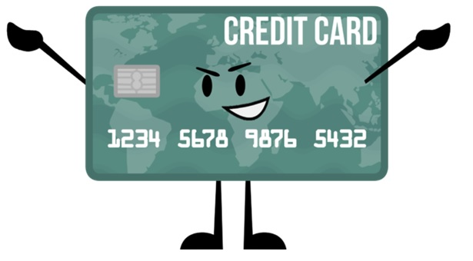
A credit card is a card issued by a financial company which enables the cardholder to borrow funds. The funds may be used as payment for goods and services. Issuance of credit cards has the condition that the cardholder will pay back the original, borrowed amount plus any additional agreed-upon charges (APR).

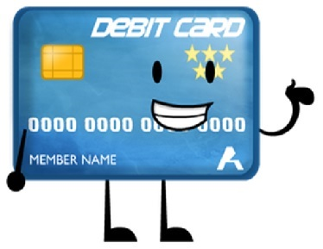
A debit card (also known as a bank card or check card) is a plastic payment card that can be used instead of cash when making purchases. It is similar to a credit card, but unlike a credit card, the money comes directly from the user's bank account when performing a transaction.

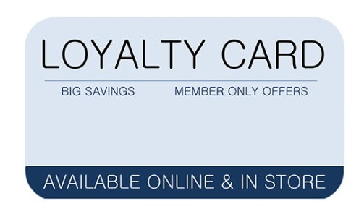
The larger stores offer customers loyalty cards. When the customer shops at the store they're awarded a set number of points depending on how much they spend. The loyalty card stores their points.

